

SEMESTER 2 EXAMINATION 2013/2014

Agent Oriented Software

COMP40040

Mr J. Dunnion
Dr. R. Collier*

Time allowed: 2 hours

Instructions for candidates

Answer any two questions

1. Answer parts (a) to (e). 50 marks in total

- What is an agent? As part of your answer, list and describe the three main features that are commonly attributed to agents.
(8 marks).
Definition (2 marks)

“an encapsulated computer system, situated in some environment, and capable of flexible autonomous action in that environment in order to meet its design objectives.”

Features (6 marks)

- Autonomous: Control over internal state and own behaviour.
- Situated: Experiences environment through sensors and acts through effectors.
- Flexible:
  - Reactive: Respond in a timely fashion to environmental change.
  - Proactive: Act in anticipation of future goals.

- “The Agent-Oriented Programming (AOP) paradigm can be viewed as a specialization of the Object Oriented Programming paradigm in which systems are built using agents.” Give Shoham’s table of comparison for AOP and OOP.
(10 marks).

Replicate table from notes:

OOP AOP
Basic Unit Object Agent
Parameters describing unconstrained beliefs, commitments,
state of basic unit capabilities
Process of Computation message passing and message passing and
response methods response methods
Types of Message unconstrained inform, request, offer
Constrains on Methods none honesty, consistency

- AgentSpeak(L) is an abstract Agent-Oriented Programming language that was proposed by Arnund Rao and which is based on the Belief-Desire-Intention architecture. Explain what is meant by beliefs, desires and intentions; describe the relationship between them and explain how these concepts are realized in AgentSpeak(L).
- marks).

Belief, Desire Intention Definitions (3 marks)
- Beliefs: the current state of the environment
- Desires: the agent ideal future state of the environment
- Intentions: subset of the desires that the agent commits to

Relationship (4 marks):
The current state of the environment is represented by the agents beliefs, while the agents desires represent the “ideal” (possibly inconsistent) state of the environment. The agent selects as subset of its desires, which it commits to bringing about and adopts them as intentions. The adopted intentions are mapped to some form of behavior which causes the environment state to change to reflect the intentions (i.e. they become beliefs).

Realisation in AgentSpeak(L) (3 marks):

- Beliefs: the current state
- Desires: represented as goals (assumed to be mutually consistent)
- Intentions: represented as plans that have been adopted to achieve goals

- List and describe the purpose of each of the 4 basic plan operators (statement types) provided in Rao’s AgentSpeak(L) and give example syntax for each one.
(12 marks).
- Query: checks if a belief holds w.r.t. the agents belief base – e.g. ?has(X)
- Update: adds or removes a belief – e.g. +likes(rem, icecream)
- Primitive Action: performs an external action – e.g. kick(ball)
- Sub-goal: adopts a new (sub) goal – !bookTickets(Event)

- AgentSpeak(L) does not have any explicit concept of iteration or selection. Illustrate how you would realize (implement) these concepts in an AgentSpeak(L) program, by writing simple programs (you only need to give the rules) to do the following:
    - Given the initial goal !printTo(5), write a program that prints out the numbers 1 to 5 (iterative example).
    - Given the initial goal !check(3), write a program that prints out whether the number is even or odd (selection example).
(10 marks).

2. Answer parts (a) to (e). 50 marks in total

- GAIA is a methodology that supports systems analysis and design using the multi-agent systems metaphor. List the domain characteristics associated with this methodology.
(8 marks).

- Agents are coarse-grained computational systems, each making use of significant computational resources.

- GAIA-designed systems maximise some global quality measure, but may be sub-optimal from the point of view of the system components.
  - Gaia is not intended for systems that admit the possibility of true conflict.

- GAIA makes no assumptions about the delivery platform.
  - Agents are heterogeneous, in that different agents may be implemented using different programming languages, architectures, and techniques.

- GAIA supports the development of closed systems.
  - The organisation structure of the system is static, in that inter-agent relationships do not change at run-time.
  - The abilities of agents and the services they provide are static, in that they do not change at run-time.
  - The overall system contains a comparatively small number of different agent types (less than 100).

- Draw a diagram outlining the main process that underpins GAIA. Include in your diagram the models that are generated and their relationship. Indicate which models are part of the design phase, and which are part of the analysis phase.
(8 marks).
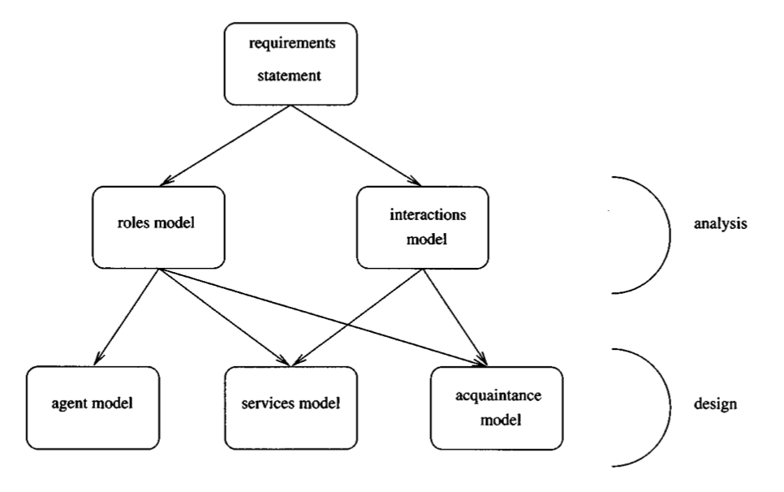

- One of the central models in the analysis phase is the roles model, which consists of a set of roles defined using a role schema template. List and explain (briefly) the purpose of the fields that make up this template.
(10 marks).

Name: The name of the role
Description: Textual description of the role
Protocols and Activities: List of the (interaction) protocols and primitive activities associated with the role
Permissions: The (information) resources required by the agent and the access writes to be attributed to those resources.
Responsibilities: Combines the normal behaviour of an agent playing the role and any invariants (safely conditions) that should be maintained.

- GAIA includes two types of responsibility. Name and describe each of these types, illustrate your answer with a practical example.
- marks).

Liveness Responsibilities (8 marks)
Those that, intuitively, state that “something good happens”. That is, they specify what must be done.
- Liveness responsibilities are things that the agent must do while playing the role. As such, they tend to follow certain patterns. For example:
  - Guaranteed Response type achievement goals take the form “a request is always followed by a response”.
  - Infinite Repetition type achievement goals take the form “x will happen infinitely often”.
- GAIA represents liveness properties as liveness expressions. These are basically regular expressions.
- A liveness expression takes the form
ROLENAME = expression
where, ROLENAME is the name of the role and expression is the liveness expression.
- The atomic components of a liveness expression are either activities or protocols.
  - Activities are fundamental actions that must be directly executable by the agent. They are represented here by activity identifiers.
  - Protocols define interactions with other roles. These are defined in the Interaction Model. They are represented here by protocol identifiers.
- These atomic components can be combined with a number of operators to form the liveness expressions.

- Example: a coffee maker, liveness responsibilities include:
  - whenever the coffee pot is empty, fill it up; and
  - whenever fresh coffee is brewed, make sure the workers know about it.

Safety Responsibilities (8 marks)
Those that, intuitively, state that “nothing bad happens”.

- They define invariants that must remain true during the execution of the role.
  - These invariants take the form of predicate expressions that define constraints which apply to the variables listed in the permissions field of a role.
- It is implicitly assumed that these responsibilities will apply across all states of the system execution.
- If the role is infinitely long, then the invariant will always remain true.

  - Example: the invariant that the coffee stock is never empty can be represented by the following safety expression:
coffeeStock > 0

- What is the purpose of the Agent Model? List and describe the qualifiers that may be used in this model. Illustrate your answer with an example (you can assume any required roles have already been specified).
(8 marks).
The agent model maps agent roles to agent types (2 marks)

Modifiers (4 marks)
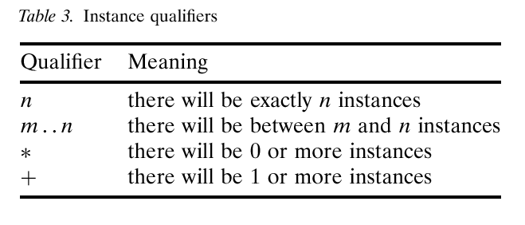
Example (2 marks)
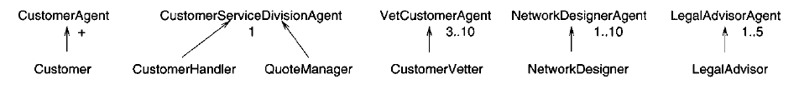
3. Answer parts (a) to (e). 50 marks in total

- Compare and contrast the Shared-Memory and Message-Based Communication Models. Your answer should describe each model and list respective the advantages and disadvantages.
(20 marks)

Shared Memory (10 marks):
- Central memory store used to manage interaction.
  - Can be simple and generic (e.g. tuple spaces)
  - Can be complex and task-oriented (e.g. blackboards)
  - Distribution and replication can be used to improve reliability
- Benefits
  - Extensibility: all agents communicate via shared space
  - Better for sharing larger quantities of data.
  - Supports 1:m (broadcast) type communication
  - Easy to monitor and manage system activities
- Drawbacks
  - Loss of Privacy: information is public
  - Information Overload: must deal with large quantities of data

Message Based (10 marks):
- Communication Channels used to route messages.
  - Transport Independent: works with HTTP, SOAP, IIOP, …
  - Focused on 1:1 private communication
  - Uses a standardised message structure
- Benefits:
  - Well suited to internet scale applications
  - Communication can be direct and (less) public
- Drawbacks:
  - Requires Agent Discovery mechanism
  - Often viewed as knowledge level interaction - not good for large scale data transfer
  - Monitoring and Management of interactions more difficult

- What is Speech Act Theory? List and explain the five main categories of speech act as identified by Searle.
(10 marks)

- Definition (5 marks):
  - The origin of speech act theories are usually traced to the work of the philosopher John Austin.
  - Austin noticed that some utterances are like ”physical actions” that appear to change the state of the world. e.g.
    - Declaring war
    - ”I now pronounce you man and wife”
  - Austin distinguished 3 different aspects of speech acts:
    - Locutionary act - act of making an utterance
      - e.g. saying ”please make some tea” ’
    - Illocutionary act – action performed in saying something
      - e.g. he requested me to make some tea
    - Perlocution – effect of the act
      - e.g. he got me to make tea
- Categories (5 marks):
  - Representatives or assertives (informing)
  - Directives (requesting)
  - Commisives (committing)
  - Expressive (express a mental state)
  - Declaratives (effect some change)

- What is an Agent Communication Language (ACL)? What is the minimum set of features required for a functioning ACL? Why is this insufficient in practice?
(8 marks)

- An Agent Communication Language combines:
  - a data format for representing speech acts.
  - a (partial) model of the state of the speaker and hearer.
  - a formally specified set of speech act types (based on the above model).

- Minimal Practical Form: performative, sender, receiver, content
  - request ( rem, bob ) “closed(door)”

- In theory:
  - speech act = performative verb + propositional content.

- In practice:
  - Contextual information, such as: who performed the speech act, and to whom it was directed.

- The following two example FIPA-ACL conversations relate to a single FIPA protocol. Explain what is happening in each conversation, identify the protocol and draw the corresponding Agent-UML protocol diagram.

Conversation 1  (request  :sender rem  :receivers (set robot)  :language ASTRA  :content “get(beer)”  )  (refuse  :sender robot  :receivers (set rem)  :language ASTRA  :content “get(beer)”  ) | Conversation 2  (request  :sender rem  :receivers (set robot)  :language ASTRA  :content “get(beer)”  )  (agree  :sender robot  :receivers (set rem)  :language ASTRA  :content “get(beer)”  )  (inform  :sender robot  :receivers (set rem)  :language ASTRA  :content “have(beer)”  )

(12 marks)

Conversation 1: (2 marks)
Rem sends a request message to Robot asking the robot to get him beer. The robot refuses to perform the task.

Conversation 2: (2 marks)
Rem sends a request message to Robot asking the robot to get him beer. The robot agrees to perform the task, and later informs Rem that he has the beer when the task is completed.

The protocol used is the FIPA Request Protocol (2 marks)

6 marks for the Agent UML Diagram
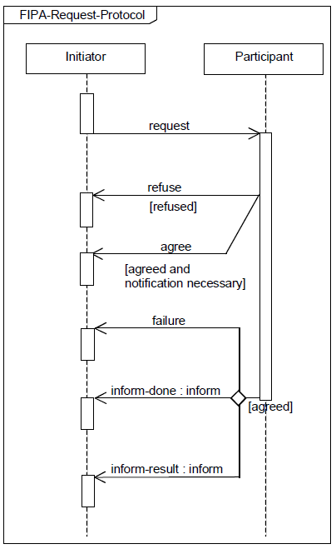

4. Answer parts (a) to (e). 50 marks in total

- List the reasons why you may need to use coordination.
(5 marks)

- Preventing anarchy or chaos
- Dependencies between agents’ actions.
- Need to meet global constraints
- No individual has sufficient competence, resources or information to solve the entire problem.
- Efficiency

- Two basic approaches to coordination are task sharing and result sharing. Describe, using examples, both of these approaches
(10 marks)

Task Sharing (2 marks): When a problem isdecomposed into subproblems and allocated to different agents.

Result Sharing (2 marks): When agents share information relevant to their subproblems

3 marks per example

- One issue that is increasingly seen as core to coordination is the underlying organizational structure through which coordination occurs. Dignum and Dignum introduced three organizational patterns: market, network, and hierarchy. Give a detailed description of the Network Pattern. Include in your answer, the objectives underpinning the design of the pattern, and the main roles in the pattern. Additionally, illustrate your answer by explaining how an agent is admitted to this organizational structure and how it would engage other member agents in achieving a required task. Include in your answer details of any interaction between agents playing key roles and the agent that is joining the structure.
(15 marks)

Objectives: (5 marks)
- Facilitate collaboration between self-interested agents that have a mutual goal.
  - Agents are willing to trade freedom in exchange for guarantees regarding security and trustworthiness.
  - Services may be traded for “soft rewards” such as increase in prestige.
  - Relationships are dependent on clear communication patterns and social norms.
  - Coordination is achieves through mutual interest, possibly via trusted third parties.
  - Coordination is governed by well-defined rules and sanctions.
- Well suited to open systems in which security and trust are essential.

Key Roles: (5 marks)
- Matchmaker
  - keeps track of needs and services of agents in system.
  - Mediates in matching of demand and supply of goods or services.
- Gatekeeper
  - responsible for accepting and introducing new agents to the market.
  - informs new agents of the possibilities and capabilities of the market.
- Notary
  - registers collaboration contracts between agents.
- Monitoring Agents
  - Trusted third parties that keep track of the execution of collaboration contracts.
Example: (5 marks)
Agent X contacts the gatekeeper to request access to the organization. Gatekeeper registers X and provides information on key matchmaker and notary agents. X contacts a matchmaker to find agents that provide the required service. The Matchmater identifies one or more relevant agents and returns details of them to X. X negotiates with these agents and reaches agreement with one of them. The two agents register their agreement with a notary who assigns a monitoring agent to monitor compliance to the agreed course of action.

- Negotiation is the process by which several agents reach agreement. One approach to implementing negotiation is to use an auction. What are the main parameters that underpin an auction and what possible values exist for each parameter?
(8 marks)
Value of goods | Private,  public/common,  Correlated
Winner determination | First price,  second price
Bids may be | Open cry,  Sealed
Bidding may be | One shot,  ascending,  descending

- Describe how English and First-Price Sealed Bid Auctions work. For each auction, list the parameters of the auction, and the dominant strategy. If it is susceptible to winners curse, explain why.
(12 marks)

(6 marks per auction)

- English auctions are:
  - First price
  - Open cry
  - Ascending
  - Dominant strategy: successively bid a small amount more than the highest current bid until it reaches the valuation, then withdraw.
  - Susceptible to Winners curse
    - Winner is the one who overvalues the goods on offer and may end up paying more than its worth.
- First Price Sealed Bid
  - One shot auction
  - Single round, where bidders submit a sealed-bid for the good.
  - Goods are awarded to agent that made the highest bid.
  - Winner pays price of highest bid.
  - Best strategy: bid less than true value.

